AI-Powered Personalized Learning Assistant - Top Recommended Modules

Define Scoring Formula
The recommendation scores for each employee-module pair have been calculated based on the following factors/key variables (preferred_learning_style, time_spent_minutes, and score)
- Time spent on modules (higher weight for engaged learners)
- Score received on modules (higher weight for high scorers)
- Learning style match (binary match to "Kinesthetic" as an example)

2. Normalize Inputs

Time spent and score were normalized to a scale of 0 to 100

Learning style match was simplified to binary (match = 1, no match = 0)

3. Apply the Score to the Dataset
A recommendation score was calculated for each employee-module pair using the formula:
- Time weight = 0.3
- Score weight = 0.4
- Learning style match weight = 0.3
Top recommendations were generated for different personas based on this scoring system.

4. Validate and Reflect
Validation was done using personas, and here are the top recommended modules for each persona:

1. Fast Finisher:
- E0063: Module 16, Score = 51.09
- E0165: Module 16, Score = 50.54
- E0044: Module 22, Score = 49.39

2. Deep Diver:
- E0196: Module 5, Score = 69.65
- E0171: Module 14, Score = 68.70
- E0151: Module 14, Score = 68.70

3. Passive Explorer:
No recommendations were made due to missing data for this persona (likely due to absence of scores).

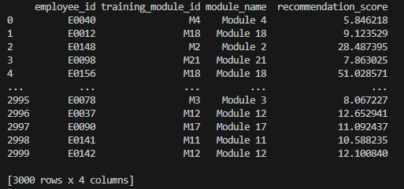
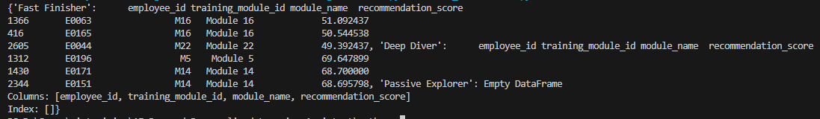
{'Fast Finisher': employee_id training_module_id module_name recommendation_score
1366 E0063 M16 Module 16 51.092437
416 E0165 M16 Module 16 50.544538
2605 E0044 M22 Module 22 49.392437, 'Deep Diver': employee_id training_module_id module_name recommendation_score
1312 E0196 M5 Module 5 69.647899
1430 E0171 M14 Module 14 68.700000
2344 E0151 M14 Module 14 68.695798, 'Passive Explorer': Empty DataFrame
Columns: [employee_id, training_module_id, module_name, recommendation_score]
Index: []}
